Landforms Project
Due 11/1
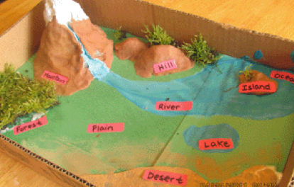
Instructions: Create a natural resources diorama.

What is a diorama?
A diorama is a model representing a scene with 3-D figures/objects.

Your Diorama Must Have The Following:

- 5 different landforms (mountain, valley, plain, island, gulf etc…)

- 4 different bodies of water (lake, ocean, river, straight, bay etc…)

- 3 different materials to build/create your diorama.

- 2 Continents (North & South America, Africa, Europe, Asia, Australia, Antarctica)

- 1 other natural resources (surprise the group)

Make Sure You:
- Label each landform and body of water

- Do your personal best and turn in a project that you’re proud of.

Please use the following rubric to create your diorama.

Landforms Rubric
Criteria | Yes | No
Five different landforms
Four-different bodies of water
Two-different continents
I created a 3-D model to demonstrate my understanding of natural resources
I used at least 3-different materials
I surprised the group and added one more natural resource to my diorama

Teacher Notes & Comments:

